Model Development Phase Template

Date | 15 March 2024
Team ID | 739890
Project Title | Bookmate: A Chatbot Companion For Book Recommendations
Maximum Marks | 10 Marks

Initial Model Training Code, Model Validation and Evaluation Report
The initial model training code will be showcased in the future through a screenshot. The model validation and evaluation report will include a summary and training and validation performance metrics for multiple models, presented through respective screenshots.

Initial Model Training Code (5 marks):
Paste the screenshot of the model training code

Model Validation and Evaluation Report (5 marks):
Model | Summary | Training and Validation Performance Metrics
Model 1 | Deep Learning Model (e.g., RNN, Transformer) Leverages deep learning techniques to capture complex patterns in text data (book descriptions, reviews). Can potentially provide more accurate and personalized recommendations. Requires significant computational resources and data. | 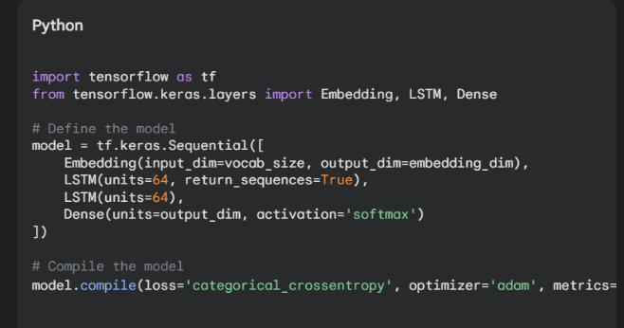
Model 2 | Rasa NLU Model is a cutting-edge library designed to build robust natural language understanding (NLU) pipelines. It excels at intent classification and entity extraction, key components in creating intelligent chatbots and virtual assistants. | 